
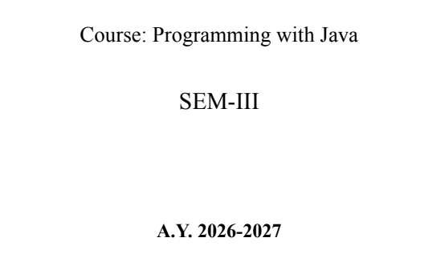
NAME: BHOOMI VIJAYVARGIYA
BATCH: A2
PRN: 25070122062
ASSIGNMENT-6
TITLE : Write a Java program to demonstrate the use of an inner class, an anonymous class.
Problem Statement: Write a Java program to demonstrate the use of an inner class, an anonymous class.
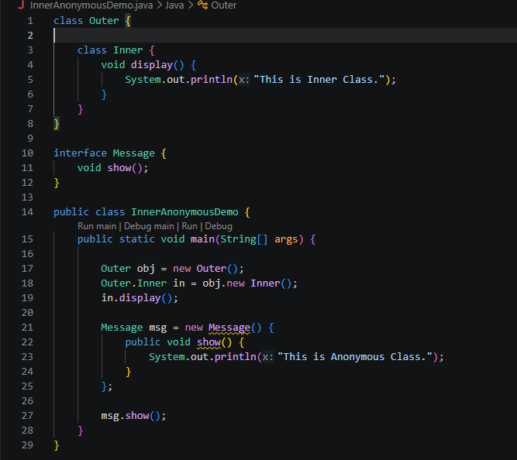
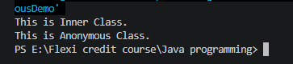
Learning Objectives: To implement inner classes and anonymous classes for improving encapsulation and event handling in Java.
Theory:
An inner class is a class defined inside another class and has access to all members of the enclosing class, including private members. Inner classes help improve code organization and logical grouping of related classes. Anonymous classes are unnamed inner classes that are instantiated only once and are mainly used for implementing interfaces or abstract classes. They simplify code by eliminating the need for separate class definitions. These concepts are widely used in Java GUI programming and event handling
Outcome
• Successfully developed a Food Delivery Application using an inner class to manage and display order details.
• Implemented an anonymous class to update and display the delivery status.
• Demonstrated the concepts of inner classes and anonymous classes in a simple real-world application.
Conclusion
• The program illustrates how an inner class helps organize related data and functionality within an outer class.
• It also demonstrates that anonymous classes are useful for implementing one-time actions, such as updating delivery status, resulting in cleaner and more concise Java code.
Exercise
- Create a Vehicle program where an inner class displays vehicle details and anonymous class performs an action.
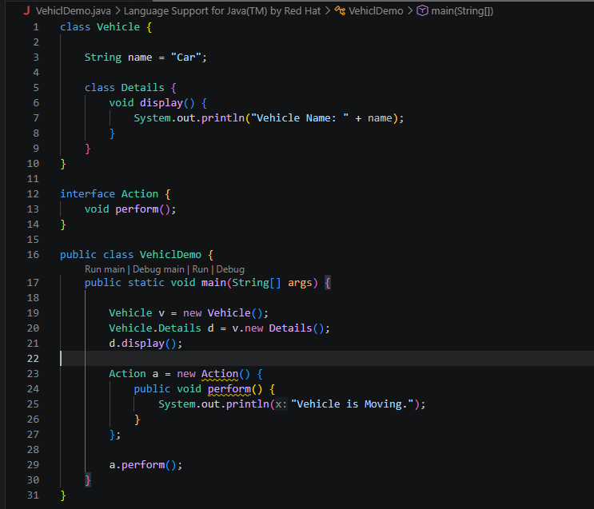
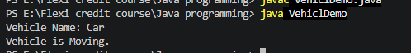
- Develop a Food Delivery Application where an inner class handles order details and anonymous classes handle delivery status updates.
